**Lab 8**

**To Practice Binary to Gray Code & BCD to Excess-3 Conversion**

***Note: You may draw all the logic diagrams with hand and paste the pictures here. Also, the conversions in the tasks can be done by hand if doing it in soft seems difficult to you.***

***Use Logicly software with your name, roll number & section mentioned in your workspace. Make sure that all of your connections are clearly visible and distinguishable. In logicly, use “text” label to point out/show all your inputs & outputs.***

**Task 1**

1. **Convert the given binary codes into respective gray codes. Mention each step while converting the codes.**

1111, 1101, 1001, 010, 011, 110

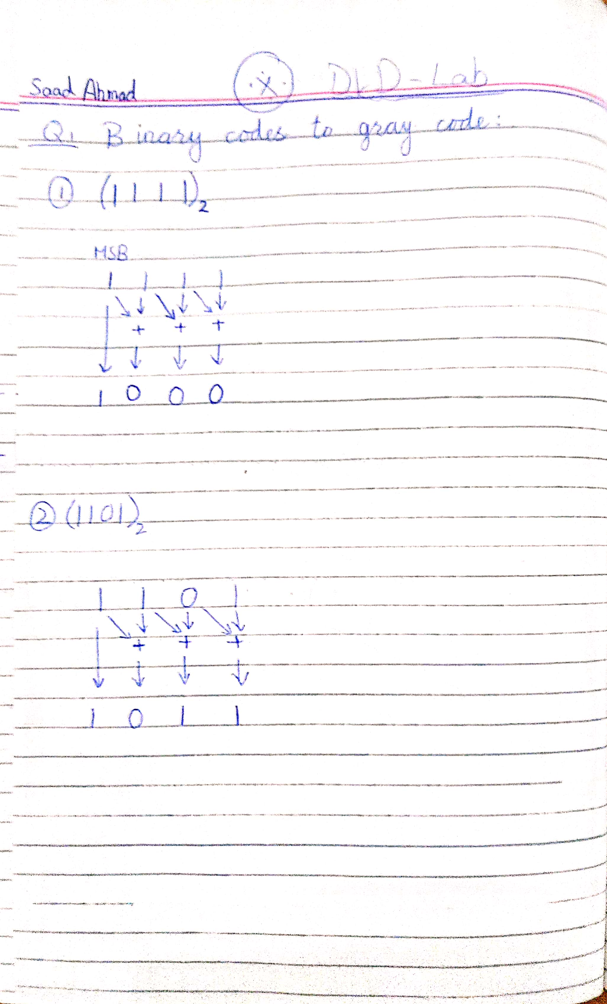

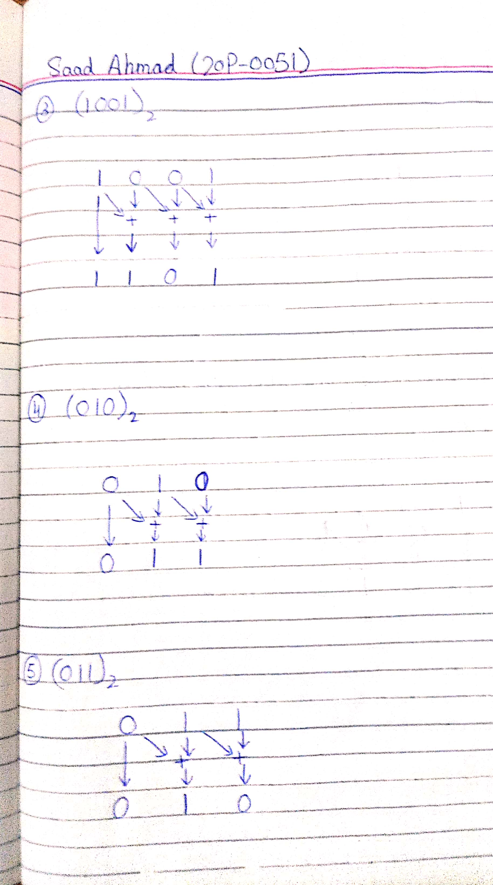

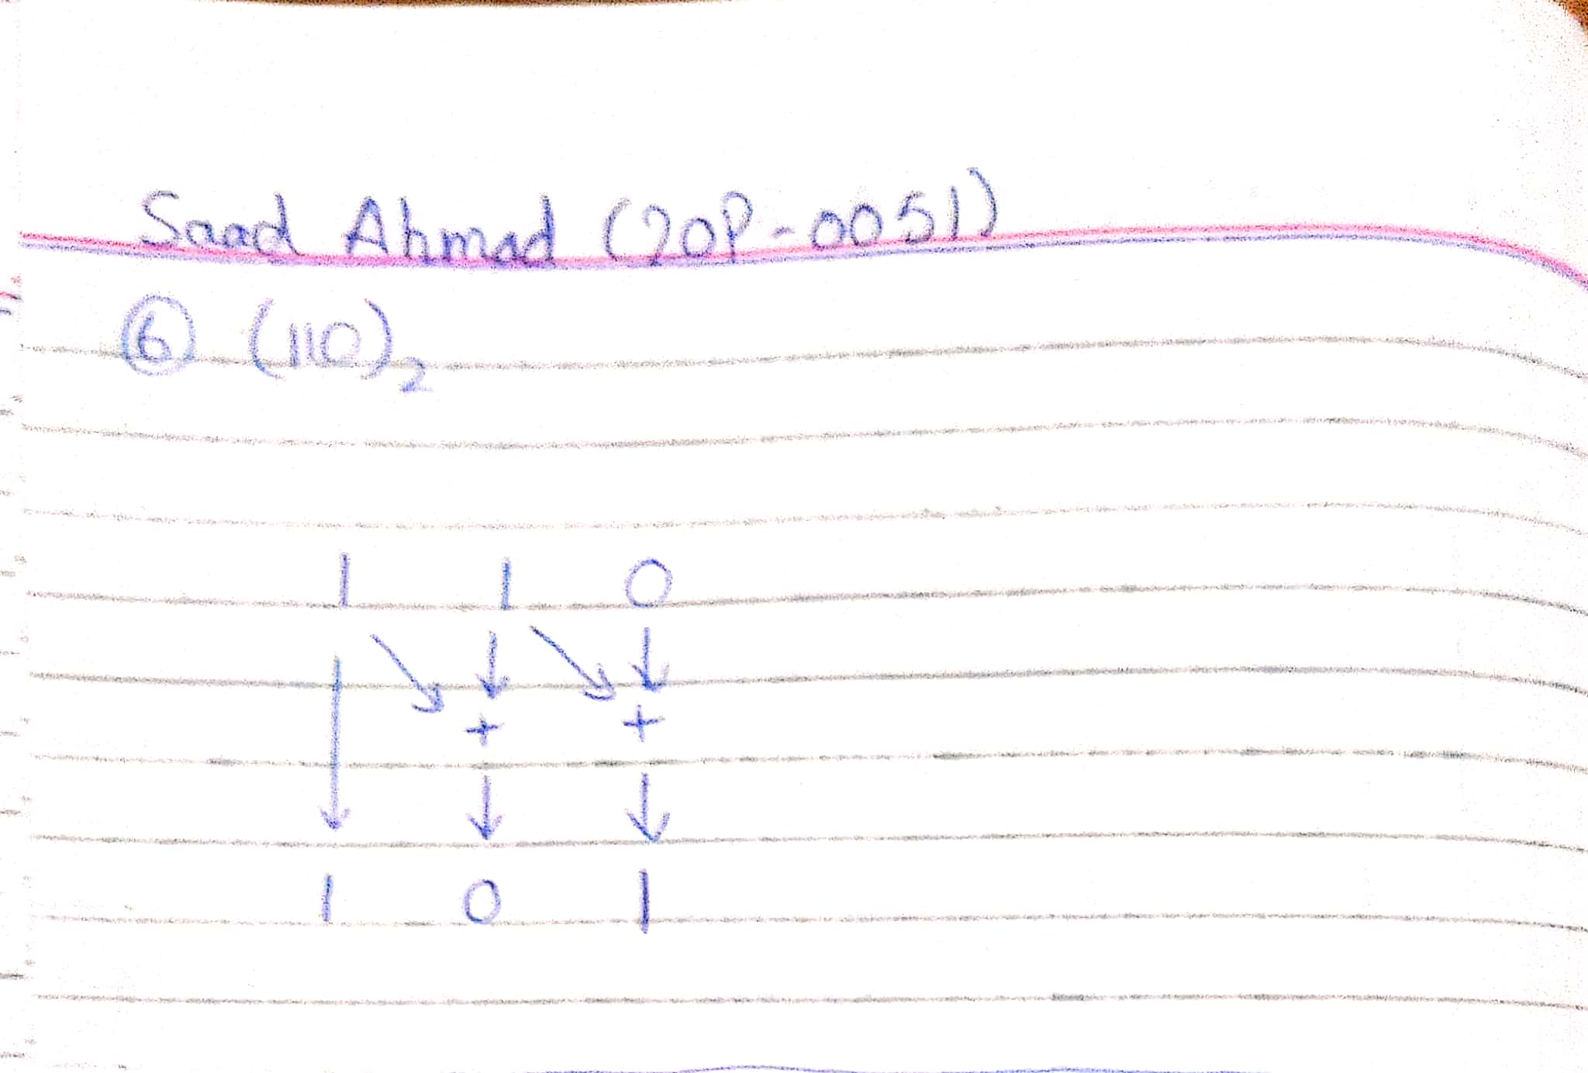

1. **Convert the given gray codes into respective binary codes. Mention each step while converting the codes.**

1011, 0101, 1100, 0100

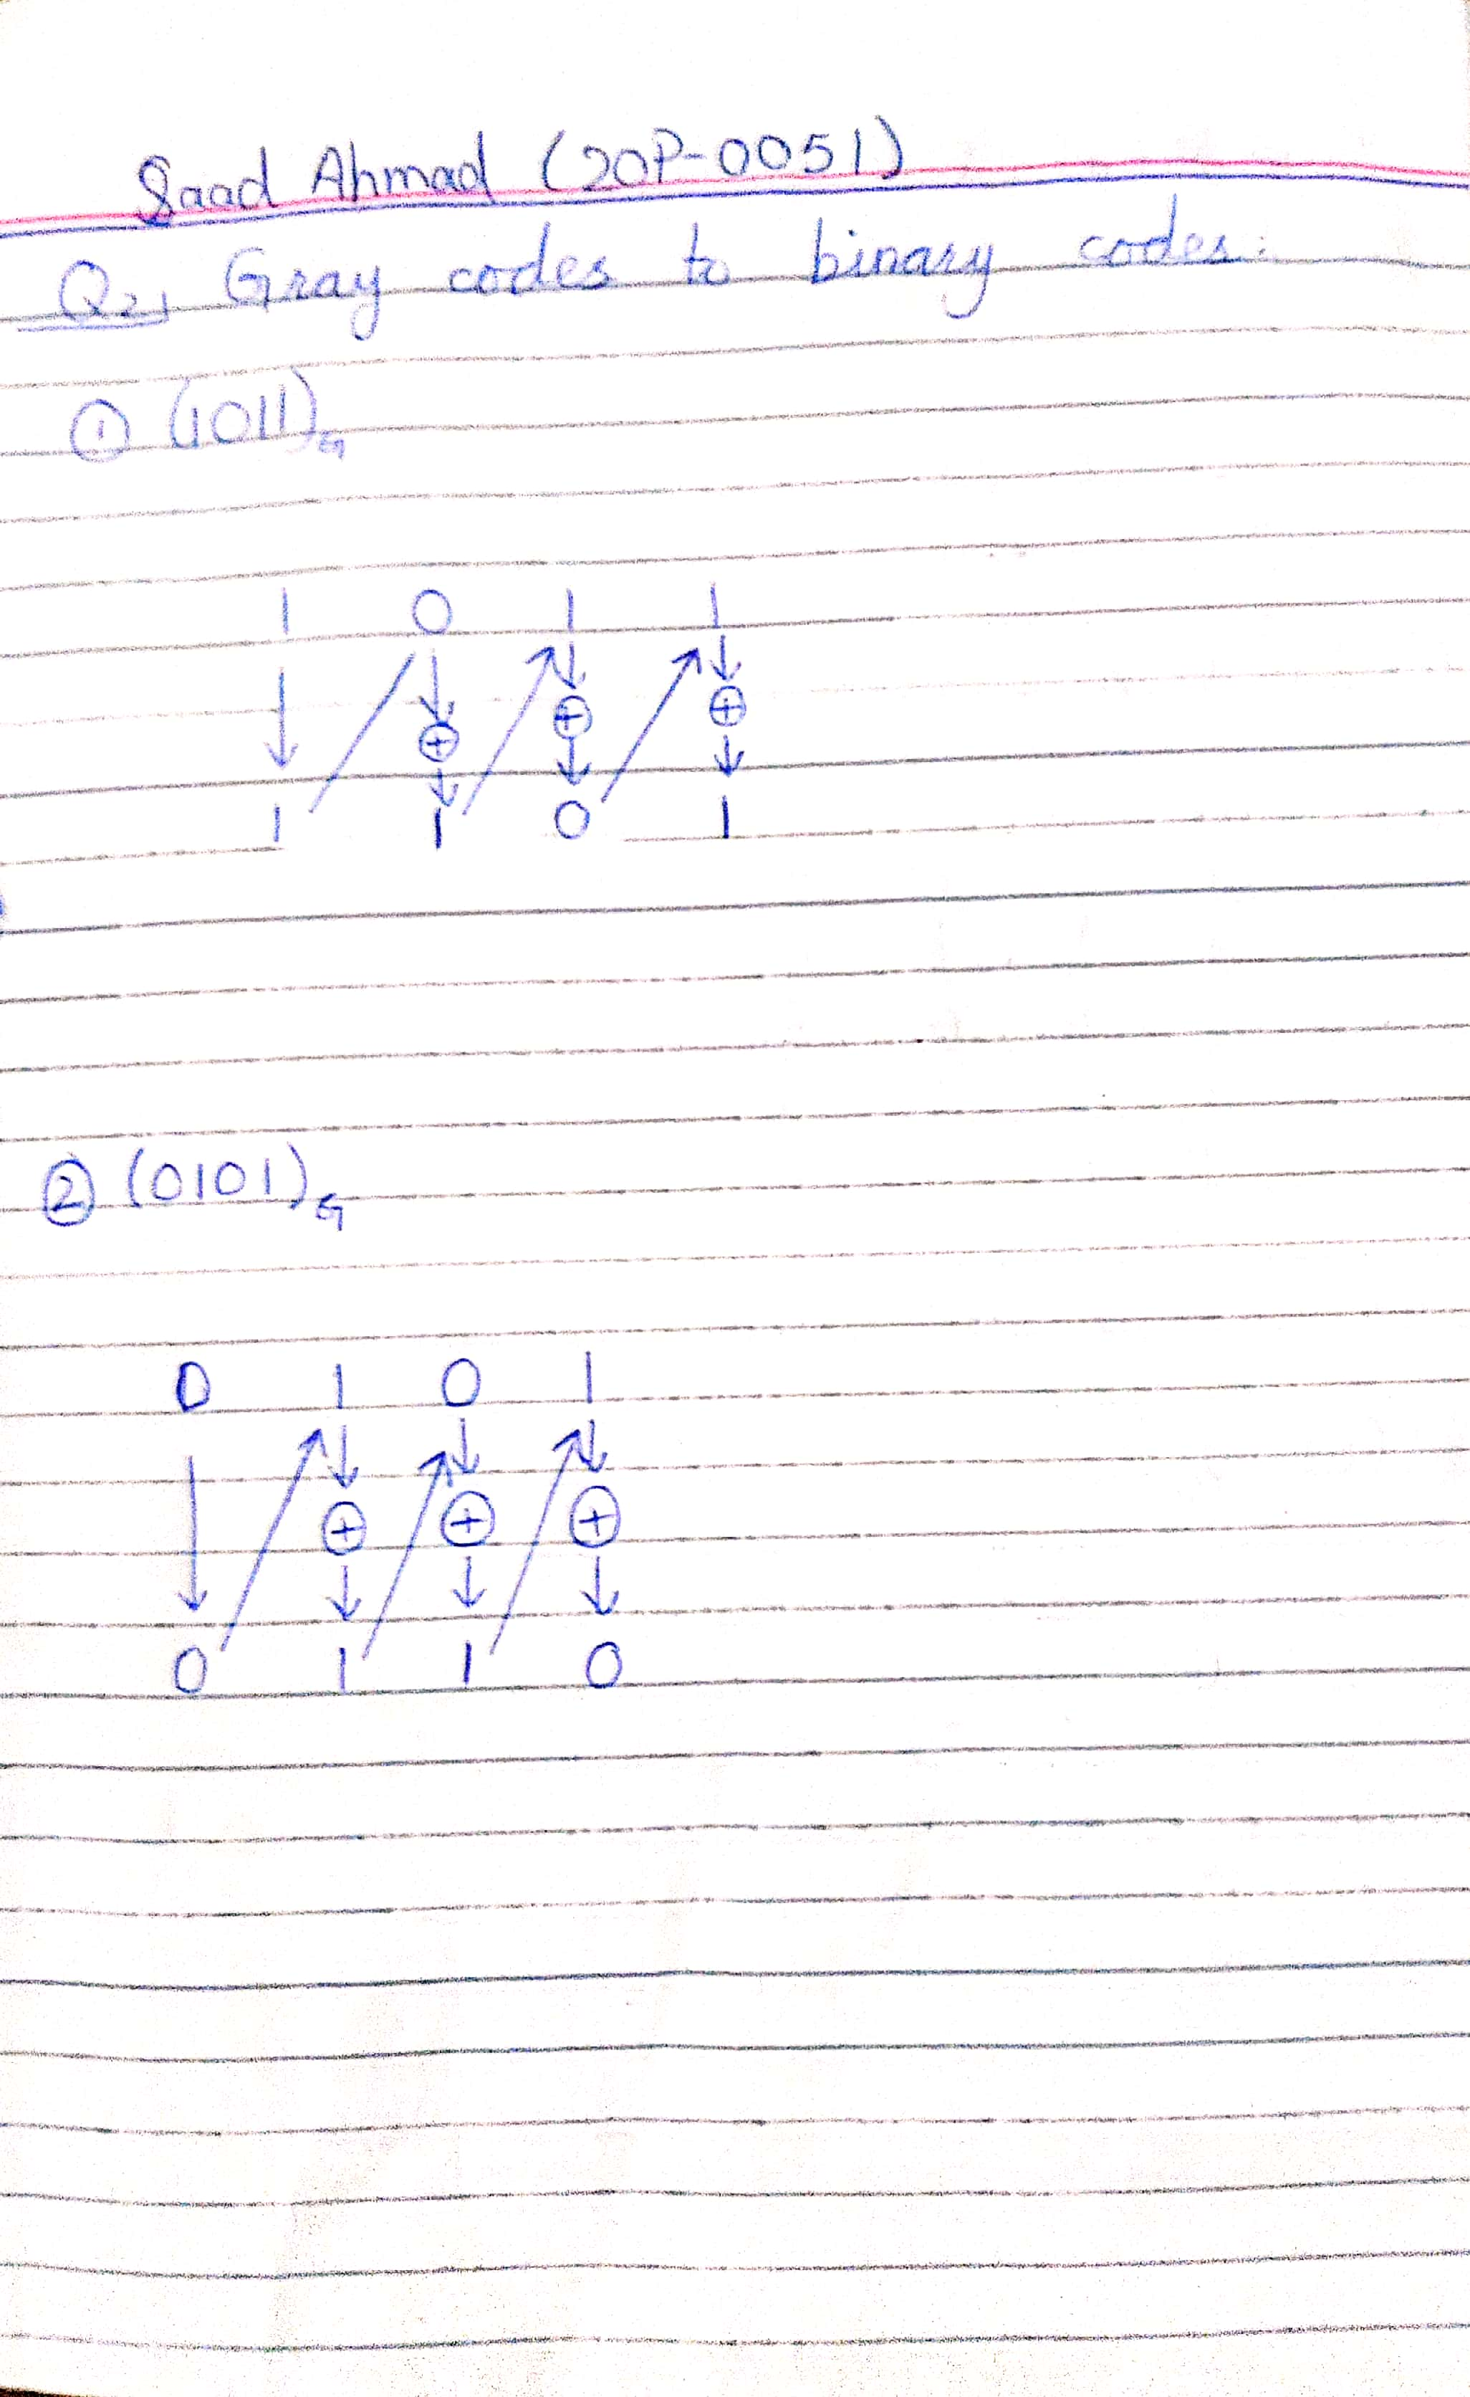

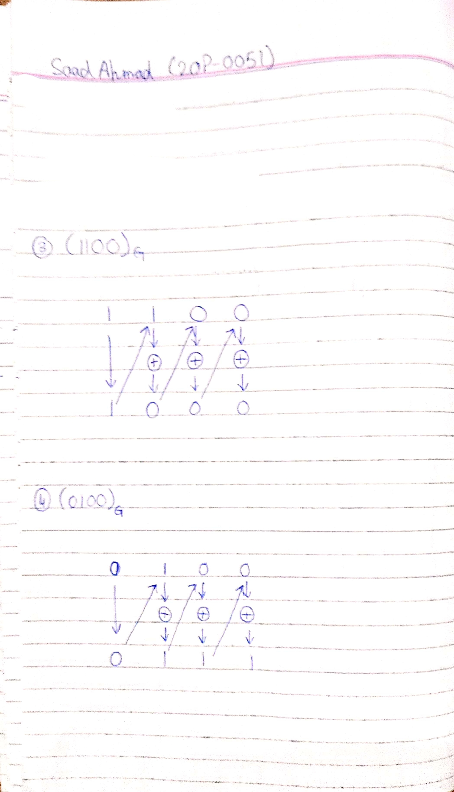

**Task 2**

**Devise a truth table for 3-bit Binary to Gray code converter. Write simplified logical expressions and simulate the logic diagram in Logicly software to verify your results. Show KMap simplification as well.**

1. Truth Table

|  |  |  |  |  |  |
| --- | --- | --- | --- | --- | --- |
| A | B | C | G2 | G1 | G0 |
| 0 | 0 | 0 | 0 | 0 | 0 |
| 0 | 0 | 1 | 0 | 0 | 1 |
| 0 | 1 | 0 | 0 | 1 | 1 |
| 0 | 1 | 1 | 0 | 1 | 0 |
| 1 | 0 | 0 | 1 | 1 | 0 |
| 1 | 0 | 1 | 1 | 1 | 1 |
| 1 | 1 | 0 | 1 | 0 | 1 |
| 1 | 1 | 1 | 1 | 0 | 0 |

1. Boolean Expression (Simplified using KMap)

G2 = AB’C’ + AB’C + ABC’ + ABC

G1 = A’BC’ + A’BC + AB’C’ + AB’C

G0 = A’B’C + A’BC’ + AB’C + ABC’

**KMap for G2**

**BC**

|  |  |  |  |
| --- | --- | --- | --- |
|  |  |  |  |
| 1 | 1 | 1 | 1 |

**A**

G2 = A

**KMap for G1**

**BC**

|  |  |  |  |
| --- | --- | --- | --- |
|  |  | 1 | 1 |
| 1 | 1 |  |  |

|  |  |  |  |
| --- | --- | --- | --- |
|  | 1 |  | 1 |
|  | 1 |  | 1 |

**A**

G1 = AB’ + A’B

**KMap for G0**

**BC**

**A**

G0 = B’C + BC’

Simplified expression for G2, G1 and G0 is:

G2 = A

G1 = AB’ + A’B

G0 = B’C + BC’

1. Logic Diagram

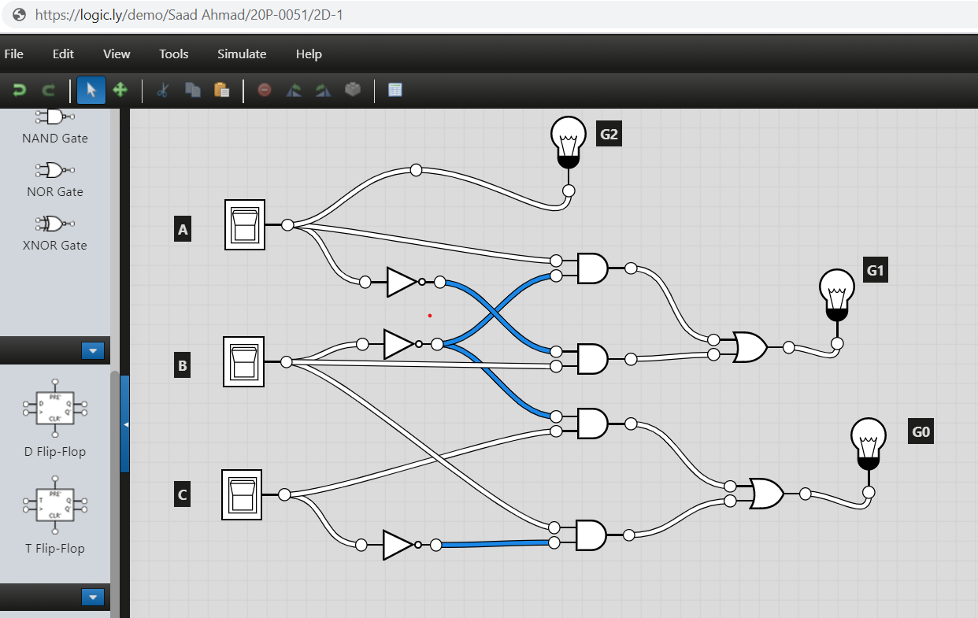

1. Software Simulation (Show here your results for a few combinations to verify the circuit)



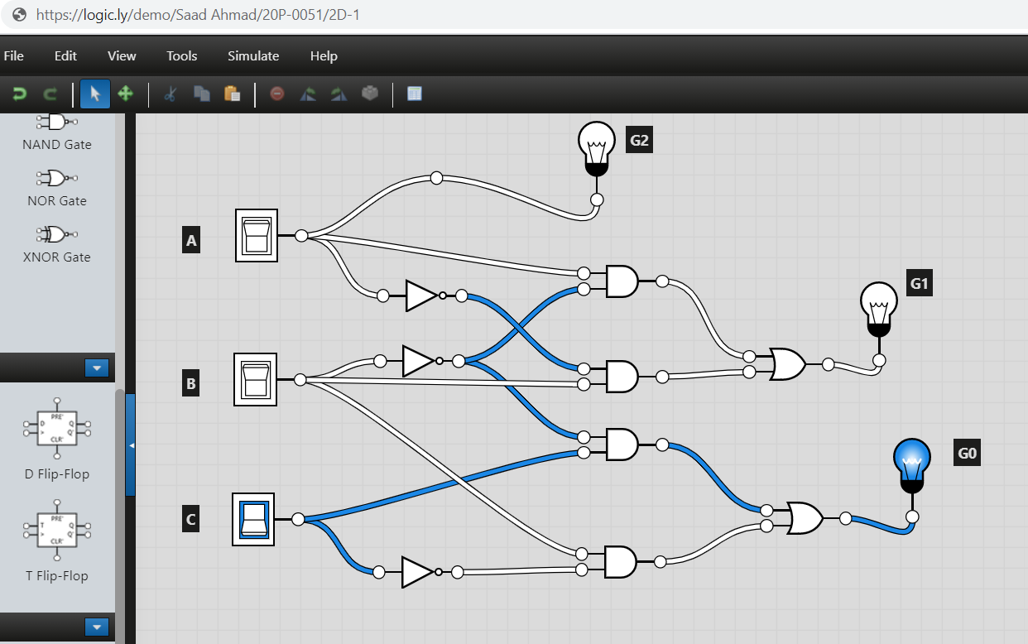

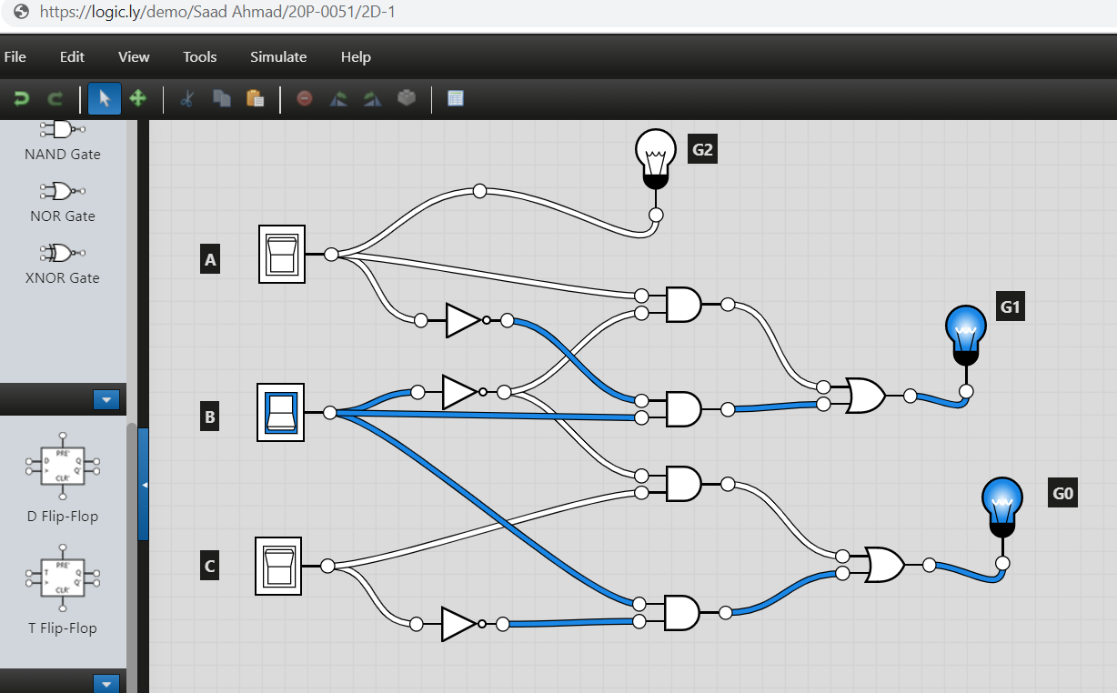

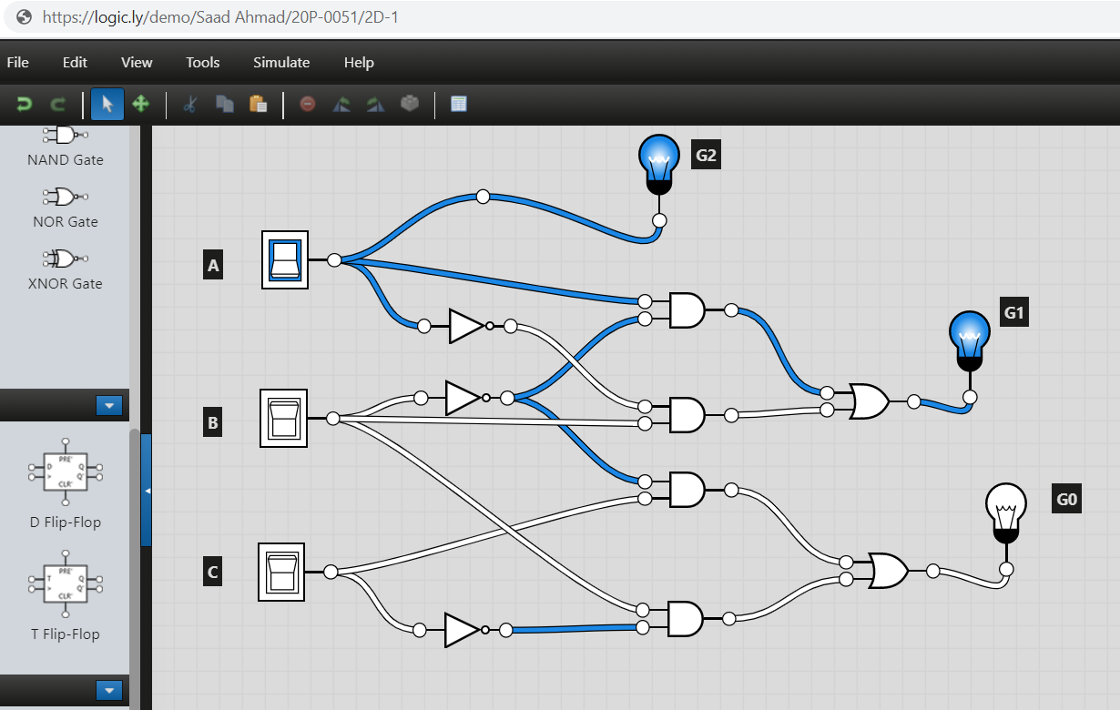

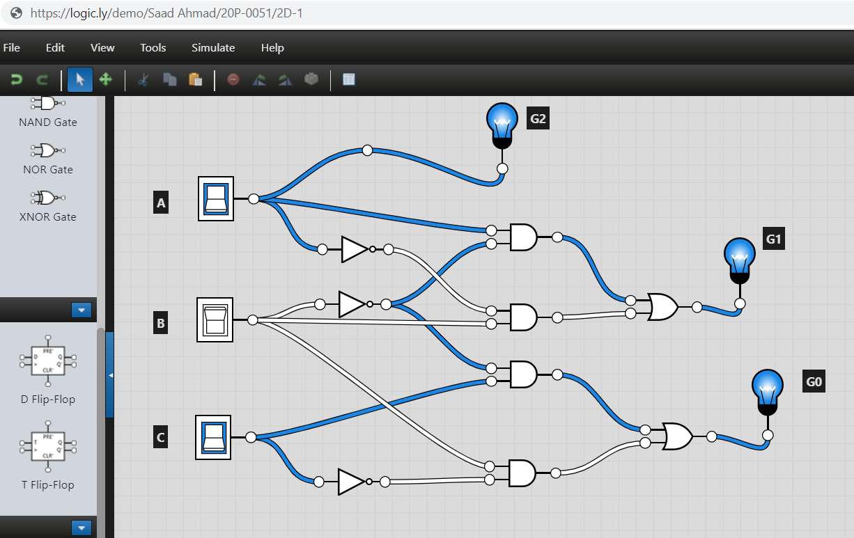

**Task 3**

1. **For the given numbers, find excess-3 codes. Mention all the steps of conversion.**

4, 9, 25, 50, 250, 405.

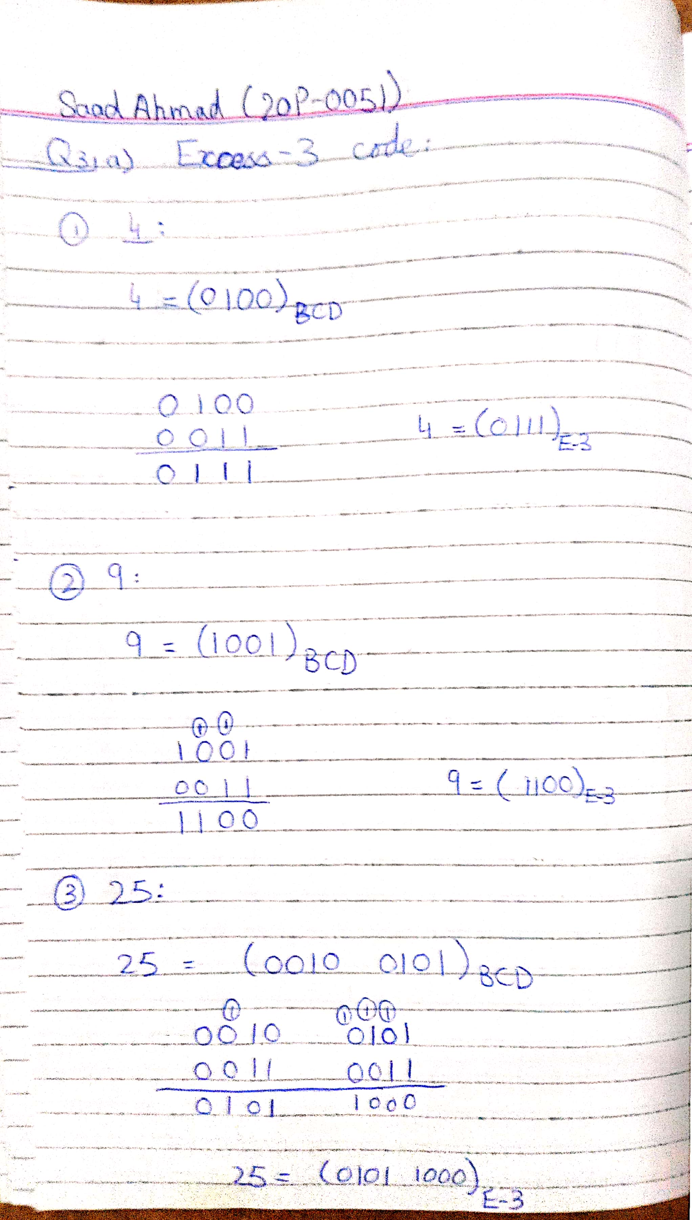

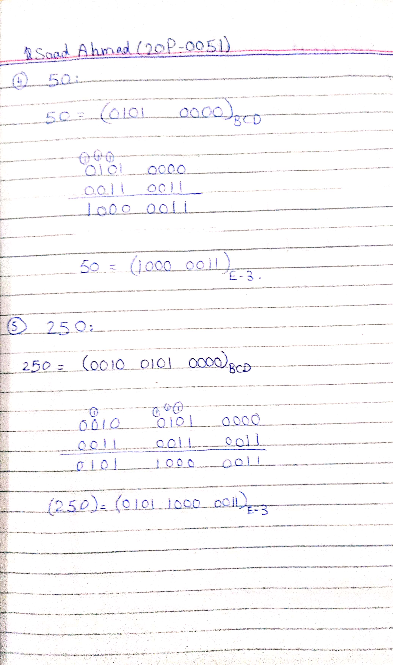

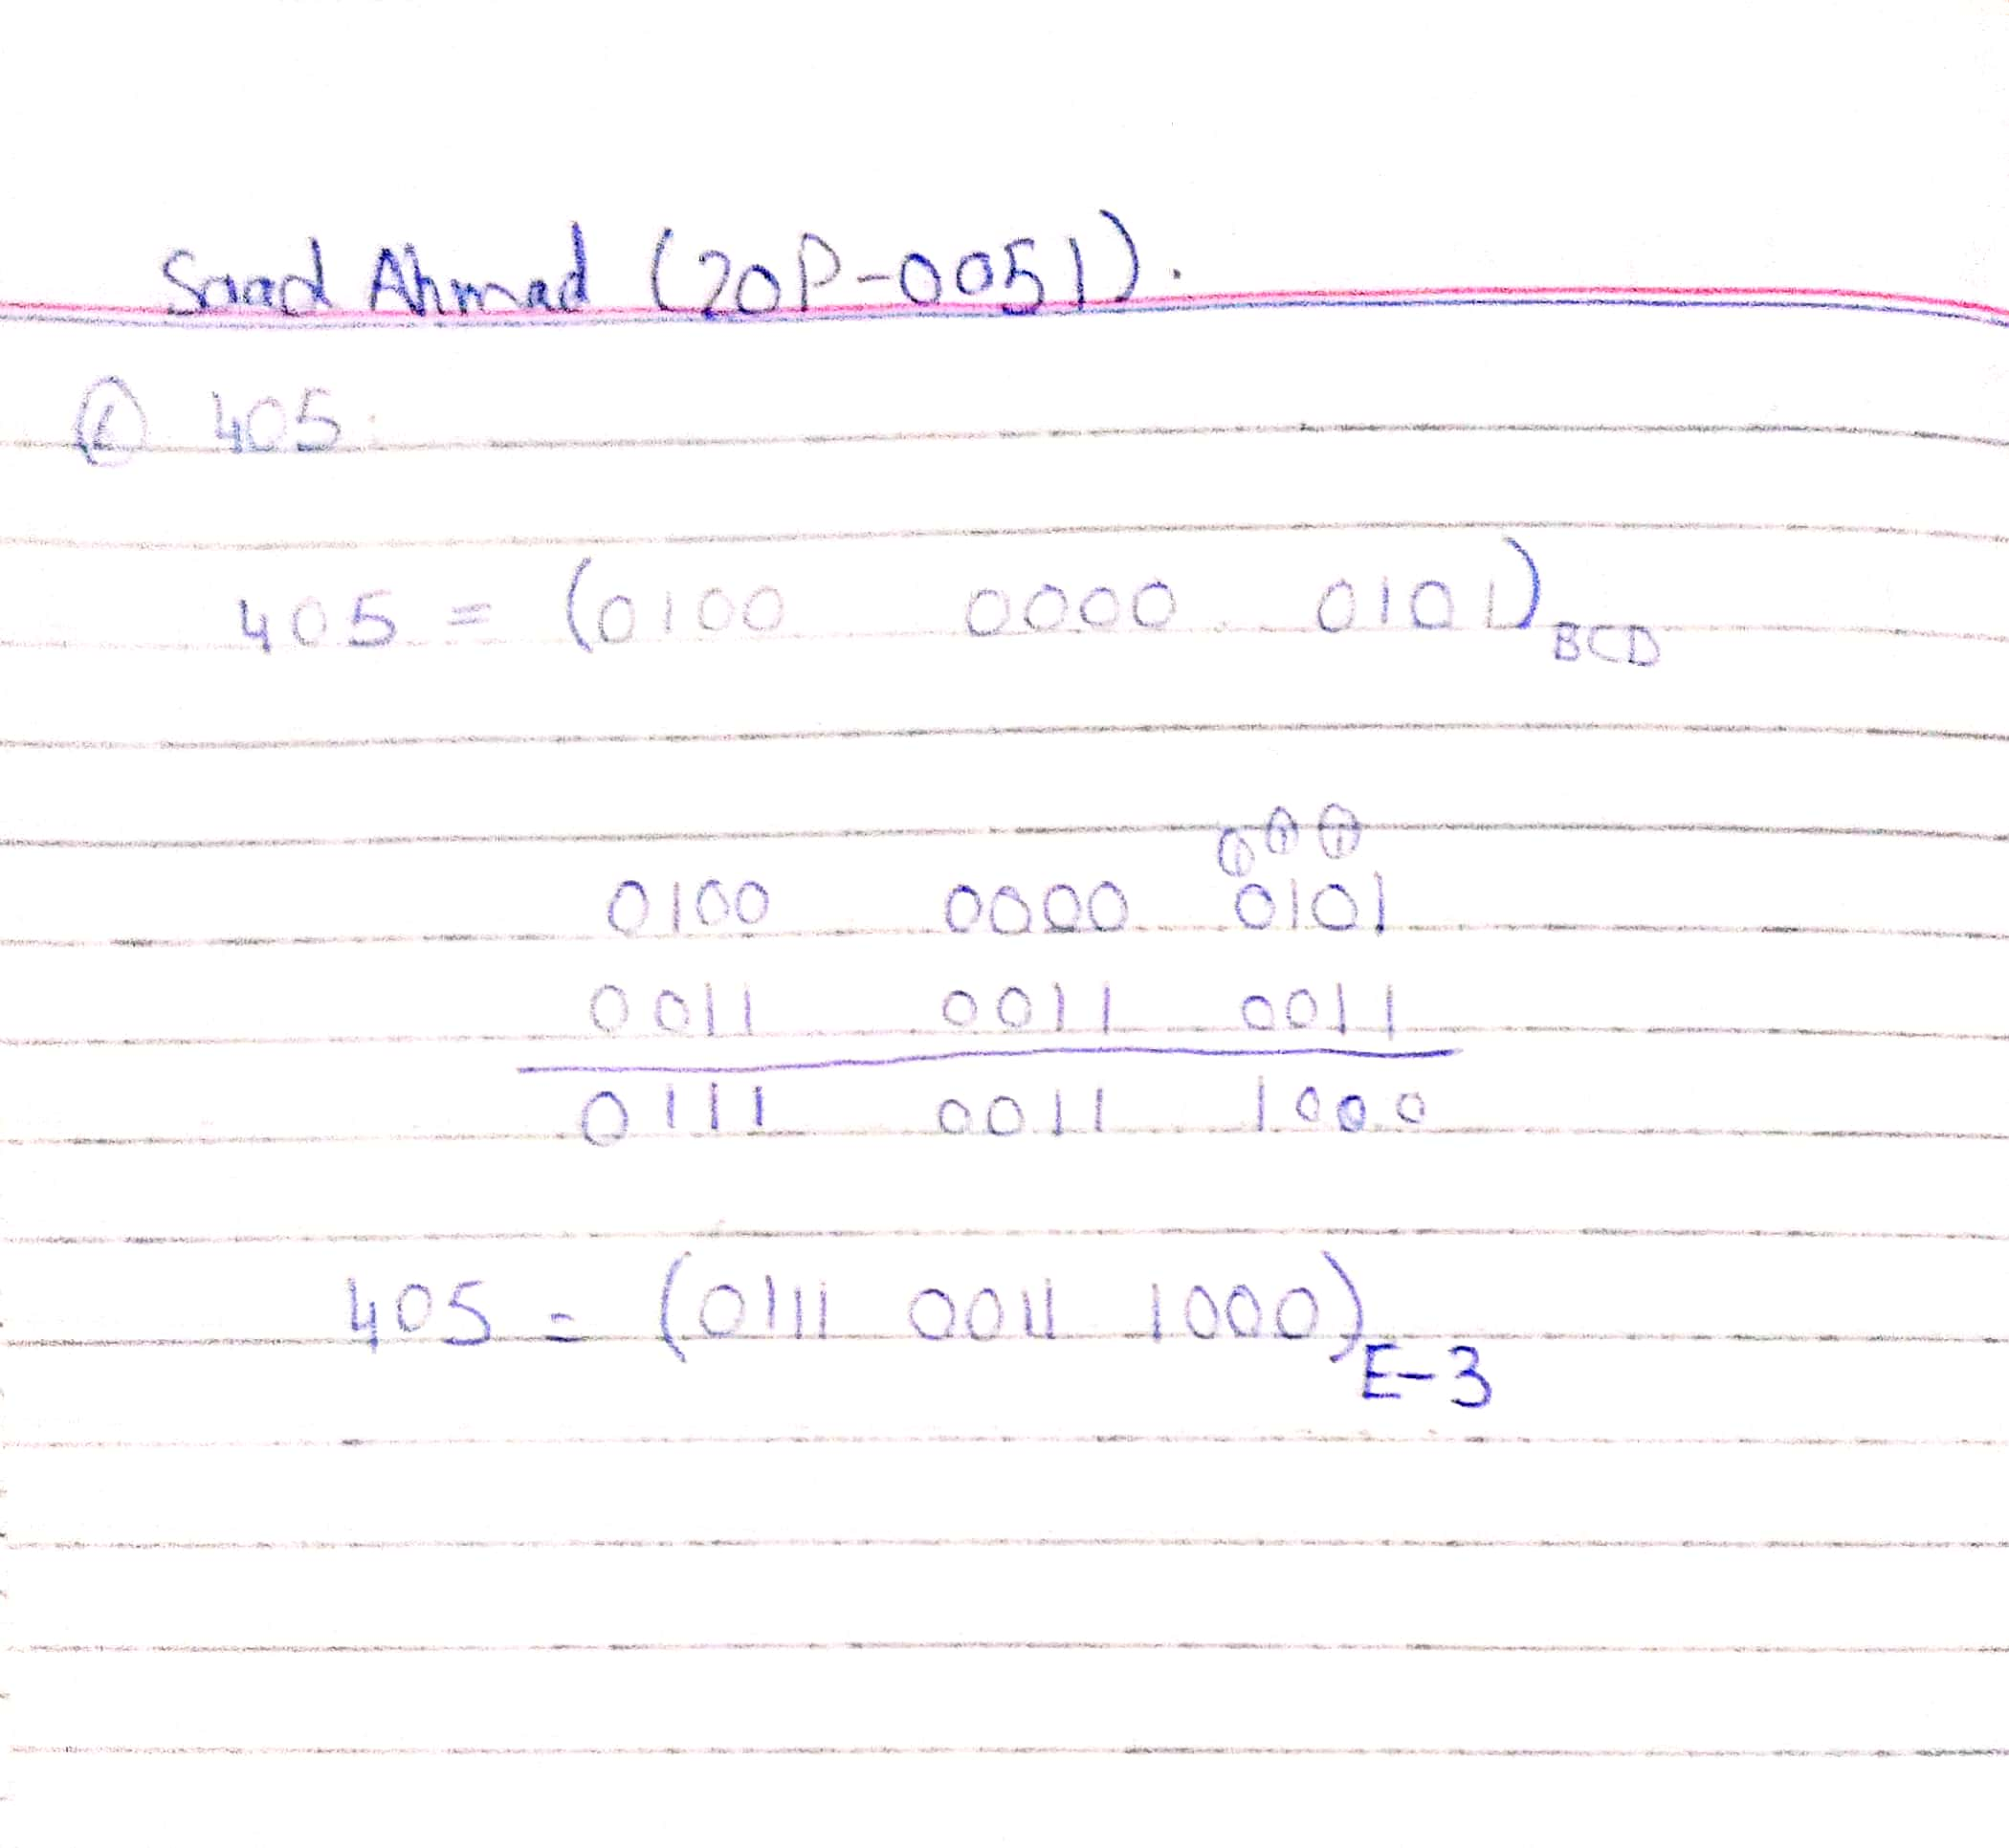

1. Devise a truth table for BCD to Excess-3 conversion (as discussed in the lecture). Write simplified expressions and simulate the logic circuit in Logicly software to verify your truth table. You may paste screenshots of a few combinations from the truth table to check your circuit.

Show your KMap simplification as well.

BCD to Excess-3 Converter

1. Truth Table

|  |  |  |  |  |  |  |  |  |
| --- | --- | --- | --- | --- | --- | --- | --- | --- |
| BCD (8421) | | | | Excess- 3 | | | | |
| A | B | C | D | W | X | Y | Z |
| 0 | 0 | 0 | 0 | 0 | 0 | 1 | 1 |
| 0 | 0 | 0 | 1 | 0 | 1 | 0 | 0 |
| 0 | 0 | 1 | 0 | 0 | 1 | 0 | 1 |
| 0 | 0 | 1 | 1 | 0 | 1 | 1 | 0 |
| 0 | 1 | 0 | 0 | 0 | 1 | 1 | 1 |
| 0 | 1 | 0 | 1 | 1 | 0 | 0 | 0 |
| 0 | 1 | 1 | 0 | 1 | 0 | 0 | 1 |
| 0 | 1 | 1 | 1 | 1 | 0 | 1 | 0 |
| 1 | 0 | 0 | 0 | 1 | 0 | 1 | 1 |
| 1 | 0 | 0 | 1 | 1 | 1 | 0 | 0 |
| 1 | 0 | 1 | 0 | X | X | X | X |
| 1 | 0 | 1 | 1 | X | X | X | X |
| 1 | 1 | 0 | 0 | X | X | X | X |
| 1 | 1 | 0 | 1 | X | X | X | X |
| 1 | 1 | 1 | 0 | X | X | X | X |
| 1 | 1 | 1 | 1 | X | X | X | X |

1. Boolean Expression (Simplified Using KMap)

**KMap for W**

**CD**

|  |  |  |  |
| --- | --- | --- | --- |
|  |  |  |  |
|  | 1 | 1 | 1 |
| X | X | X | X |
| 1 | 1 | X | X |

**AB**

W = A + BC + BD

**KMap for X**

**CD**

|  |  |  |  |
| --- | --- | --- | --- |
|  | 1 | 1 | 1 |
| 1 |  |  |  |
| X | X | X | X |
|  | 1 | X | X |

**AB**

Folded group

X = B’C + B’D + BC’D’

**KMap for Y**

**CD**

**AB**

|  |  |  |  |
| --- | --- | --- | --- |
| 1 |  | 1 |  |
| 1 |  | 1 |  |
| X | X | X | X |
| 1 |  | X | X |

Y = CD + C’D’

**KMap for Z**

**CD**

**AB**

|  |  |  |  |
| --- | --- | --- | --- |
| 1 |  |  | 1 |
| 1 |  |  | 1 |
| X | X | X | X |
| 1 |  | X | X |

Z = D’

Folded group

1. Logic Diagram

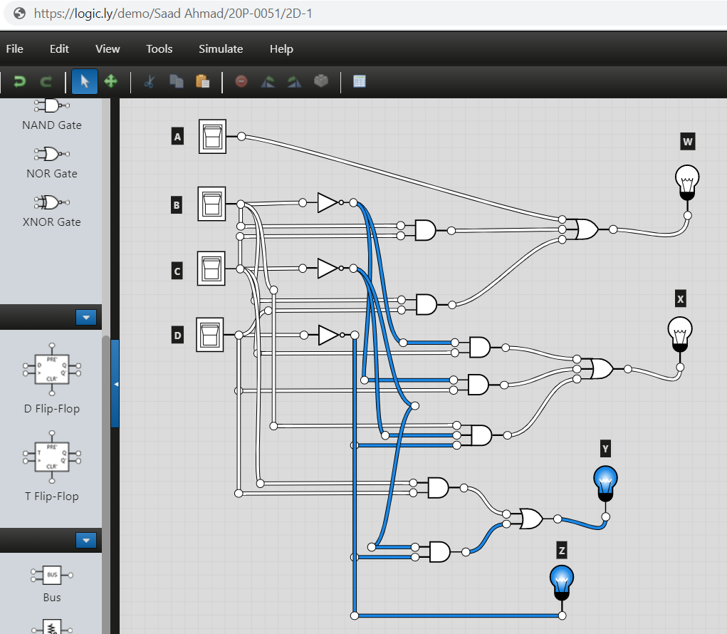

1. Software Simulation (Show here your results for a few combinations to verify the circuit)